Performance Testing
Date | 25-09-2026
Team ID | SWTID-2026-2919
Project Name | AI FitTrack
Maximum Marks | 5 Marks

Performance Testing
Performance testing evaluates how the AI FitTrack system behaves under expected and peak load conditions. It helps identify response times, system stability, resource usage, and error rates. The project uses Node.js, Express.js, MongoDB, and Google Gemini AI.

Step 1: Testing Overview
Field | Details
Testing Tool Used | Thunder Client
Type of Testing | API Functional Testing (Performance testing not yet conducted)
Target Module / API | Authentication, Workout Management, AI Workout Recommendation, and AI Fitness Insights
Test Environment | Local environment
Test Date | 25-09-2026

Step 2: Test Scenarios
S.No. | Test Scenario / Description | No. of Virtual Users | Duration (sec) | Expected Outcome
1 | User Registration API | 1 | Not measured | User account should be created successfully.
2 | User Login API | 1 | Not measured | User should receive an authentication token.
3 | Workout Management API | 1 | Not measured | Workout records should be created, retrieved, updated, and deleted successfully.
4 | AI Workout Recommendation API | 1 | Not measured | AI should generate a personalized workout recommendation.

Step 3: Performance Test Results
S.No. | Metric | Target Value | Actual Value | Status | Remarks
1 | Response Time (Avg) | < 2 seconds | Not measured | Not Tested | Requires performance testing.
2 | Response Time (Max) | < 5 seconds | Not measured | Not Tested | Requires performance testing.
3 | Throughput (Req/sec) | Not specified | Not measured | Not Tested | Requires load testing.
4 | Error Rate | < 1% | Not measured | Not Tested | Requires load testing.
5 | CPU Utilization | < 80% | Not measured | Not Tested | Requires system monitoring.
6 | Memory Utilization | < 80% | Not measured | Not Tested | Requires system monitoring.

Step 4: Observations & Analysis
The AI FitTrack backend was tested locally using Thunder Client to verify the functionality of its API endpoints. User registration, login, profile management, workout operations, and AI features were tested.
The application successfully performed the tested API operations. However, load testing and stress testing have not been conducted. Therefore, response time, throughput, CPU utilization, memory utilization, and error rate under heavy load are not yet verified.
Further performance testing is required to evaluate the system under multiple simultaneous users and identify possible performance bottlenecks.

Step 5: Screenshots / Evidence
Attach the following screenshots as evidence:

- Thunder Client screenshot showing successful user registration and login.
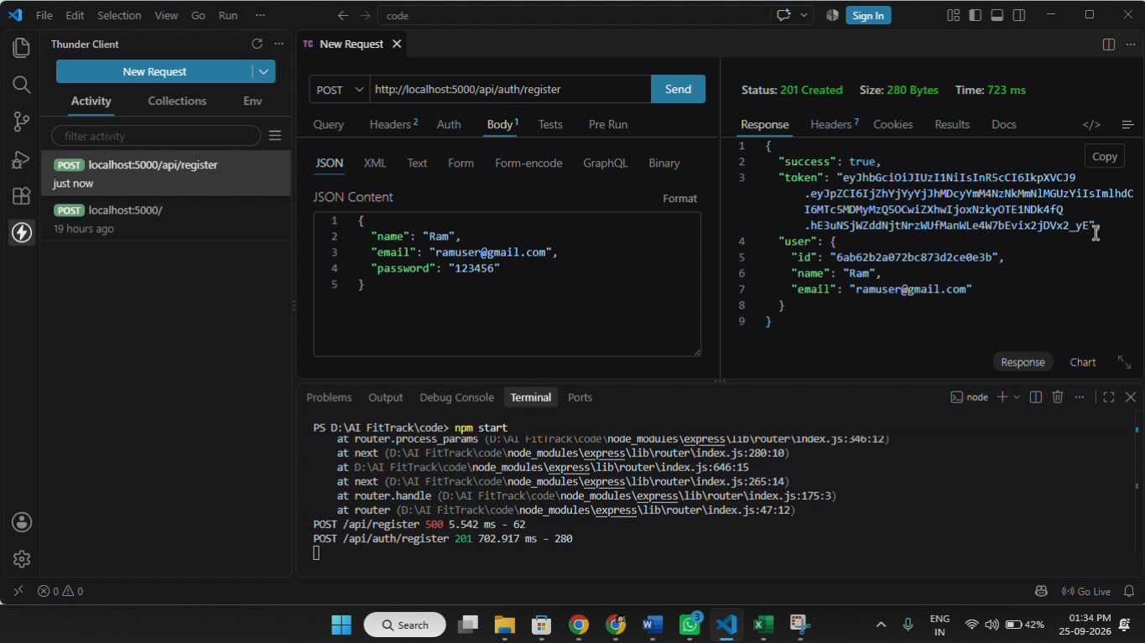

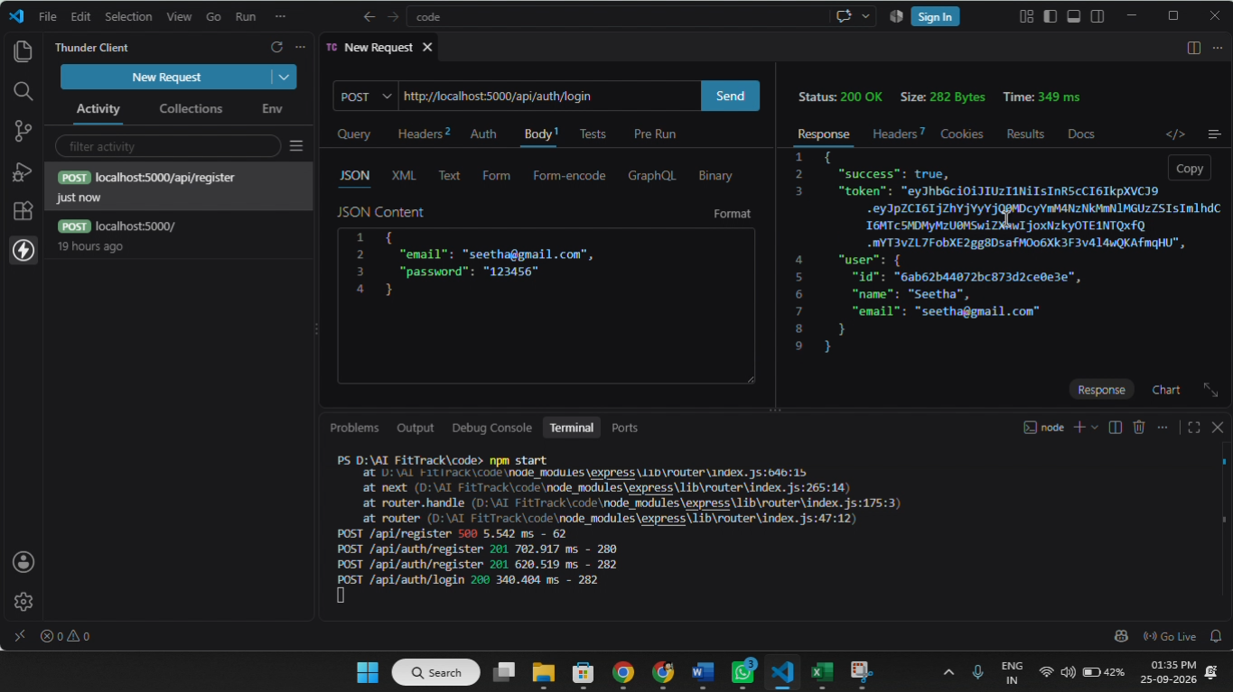

- Screenshot showing successful workout API operations.
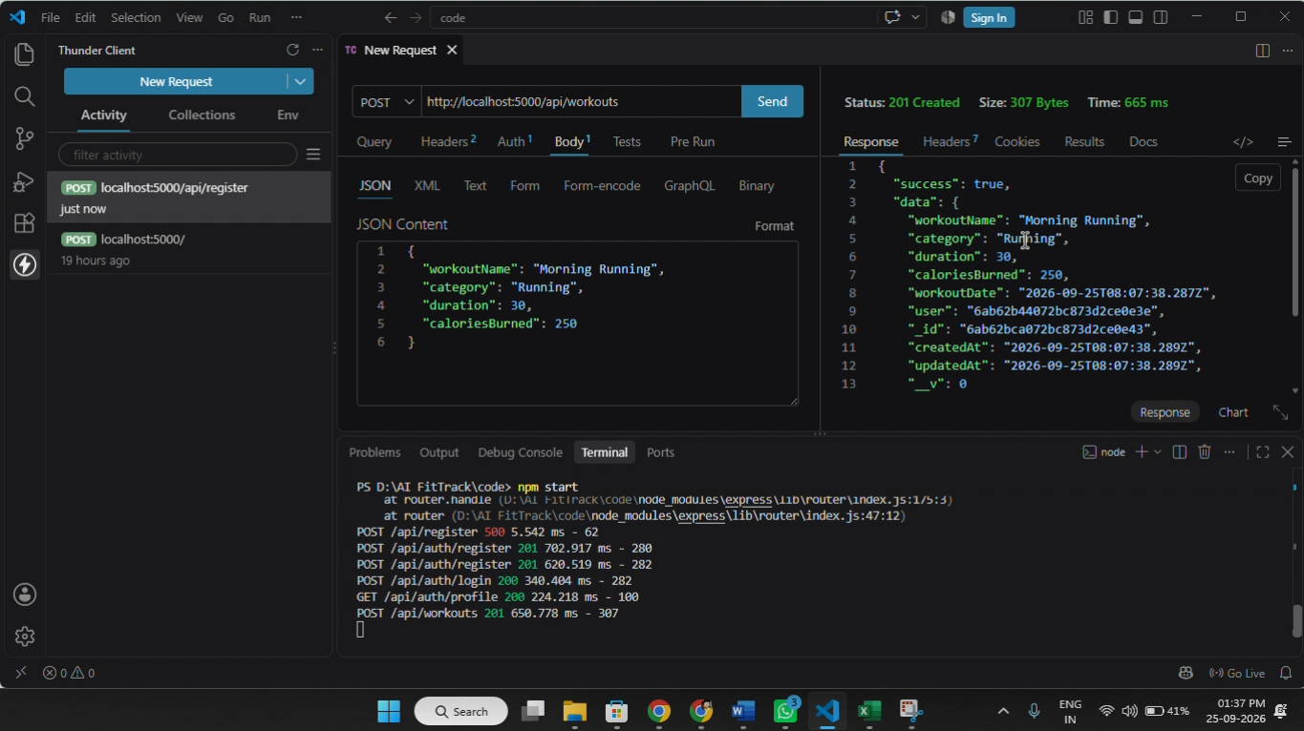

- Screenshot showing the AI workout recommendation response.
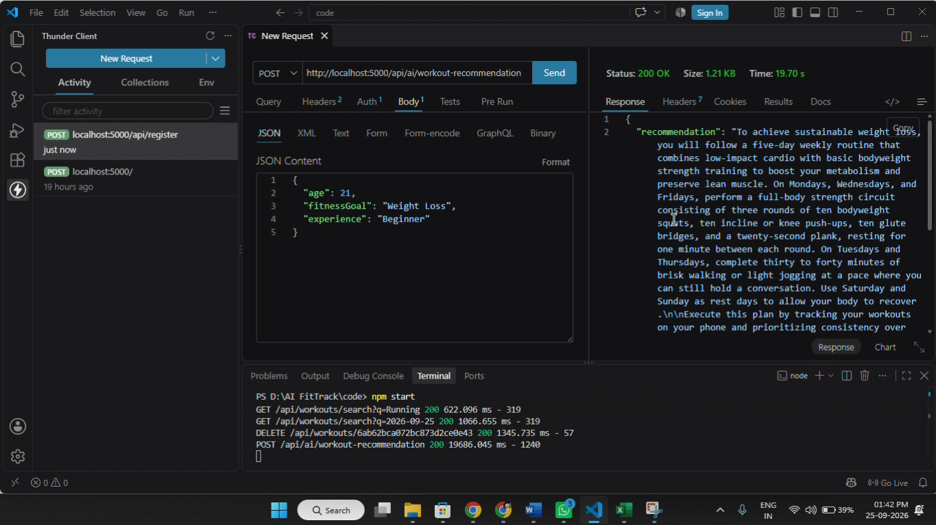

- Screenshot showing the AI fitness insights response.
